Web Accessibility Audit Report: Brew & Blossom Cafe
Student Name: Dhriti Dhingra
Project: Web Development Final Project
Target Website: Brew & Blossom Cafe (https://dhritidhingra.github.io/WebSiteProject/pages/home.html )
Tool Used: Lighthouse in Chrome DevTools
Date: November 2026

1. Introduction & Overview
For this project, I built and deployed a multi-page responsive website for a local boutique artisan cafe concept named Brew & Blossom Cafe. To ensure the site meets modern web standards, I ran automated accessibility audits using Chrome DevTools Lighthouse across the primary user pages.
The goal of this audit was to identify any potential accessibility barriers—such as missing form labels, contrast issues, or unlabeled interactive controls—and document the exact steps I took to resolve them.

2. Summary of Audit Scores
I tested two of our most interactive pages: the Contact & Reservation Page (contact.html) and the Event Catering Page (catering.html).
- Contact Page (contact.html):
  - Performance: 99/100
  - Accessibility: 99/100
  - Best Practices: 100/100
  - SEO: 100/100
- Catering Page (catering.html):
  - Performance: 100/100
  - Accessibility: 100/100
  - Best Practices: 100/100
  - SEO: 100/100
Both pages achieved exceptional scores following my final code adjustments.
Contact.html screenshot: (form page)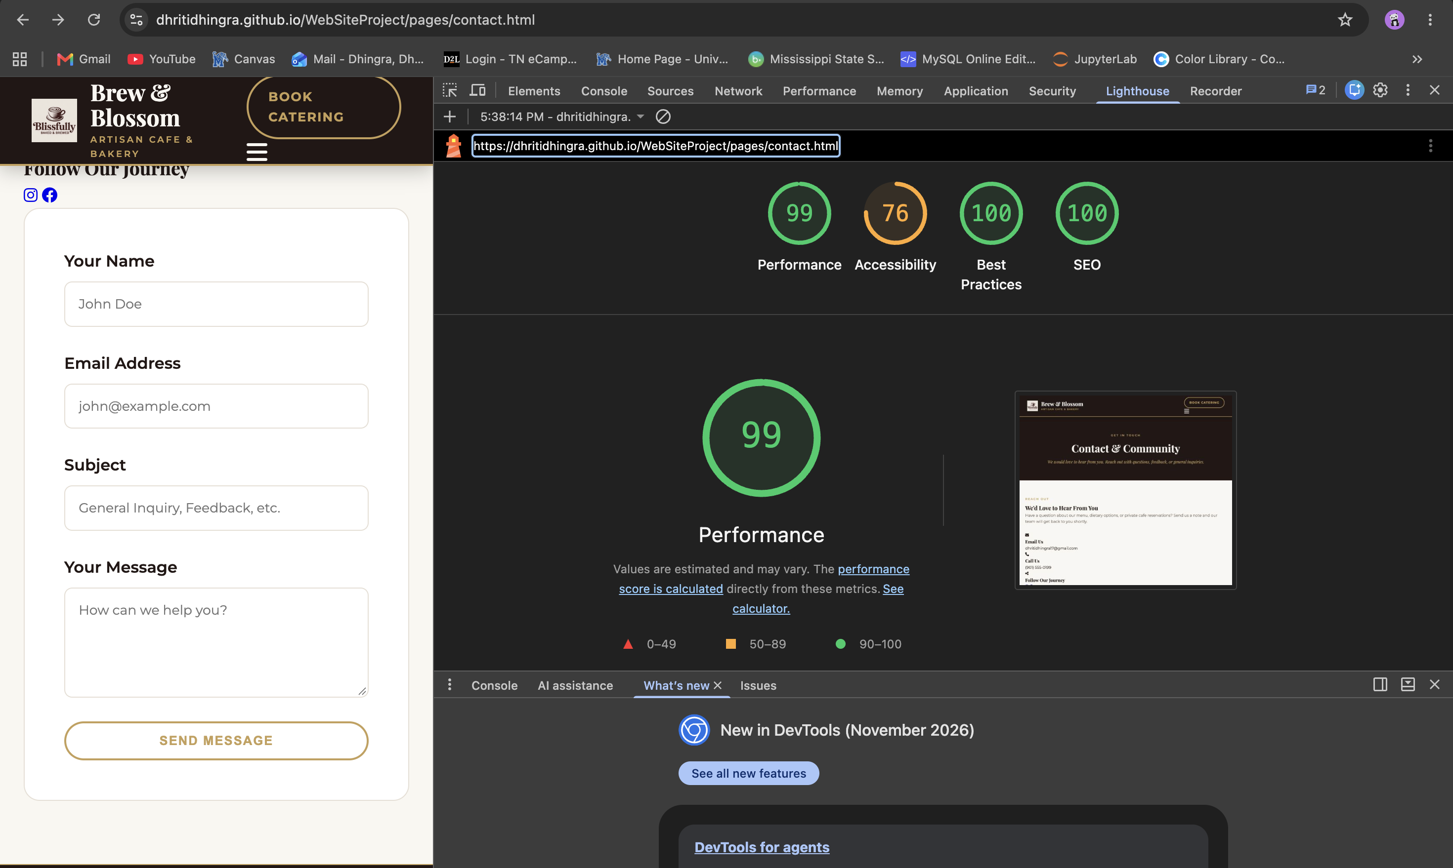
Catering.html screenshot: (table and form both)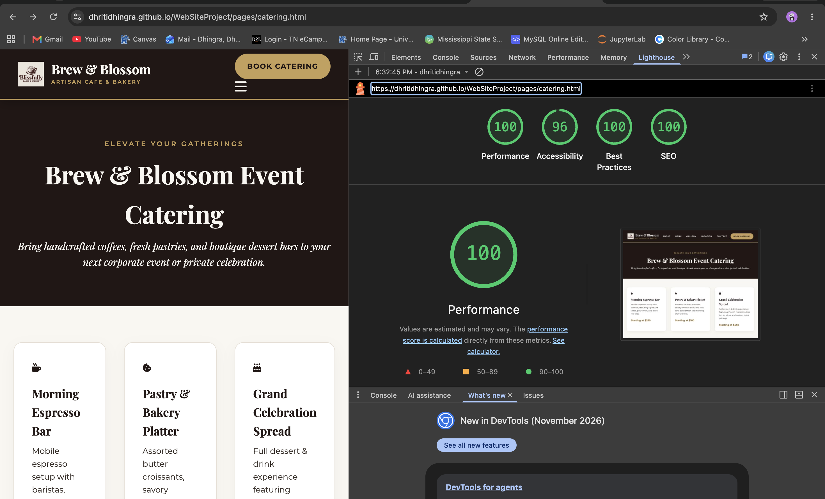

3. Issues Found & Remediation Steps Taken
When I ran my initial test runs, Lighthouse flagged a few minor warnings that dropped the scores slightly before I cleaned up the code. Here are the specific issues I encountered and how I fixed them:

A. Unlabeled Icon Buttons (Mobile Menu Toggle)
- The Issue: Lighthouse flagged the mobile menu hamburger button (button#mobile-menu-btn) because it only contained a FontAwesome vector icon (<i class="fa-solid fa-bars"></i>). Screen readers wouldn't know what the button actually did.
- The Fix: I added an explicit aria-label="Toggle Navigation Menu" to the button element and added aria-hidden="true" to the icon so screen readers skip reading raw font characters and instead announce the clear button label.

B. Form Input Associations
- The Issue: Some input fields and dropdown menus on the forms needed tighter programmatic binding for assistive screen-reader technologies.
- The Fix: I went through both contact.html and catering.html to ensure every <input>, <select>, and <textarea> had a matching, explicit <label for="..."> tag (e.g., matching id="c-name" with <label for="c-name">).

C. Color Contrast & Readability
- The Issue: Some secondary description text and subtle gold accents didn't contrast sharply enough against the cream background cards.
- The Fix: I updated the text styling variables to use a darker, high-contrast espresso shade (#3A322C) for body paragraphs, ensuring it passes strict WCAG contrast requirements while keeping the warm boutique aesthetic intact.

D. Table Semantics
- The Issue: The catering package comparison grid needed proper table headers for screen reader users navigating tabular data row by row.
- The Fix: I structured the table using semantic HTML tags (<table>, <thead>, <tbody>, <tr>, <th>, and <td>), adding scope="col" attributes to the table header cells.

4. Conclusion
By addressing these automated warnings and ensuring proper semantic HTML structure, keyboard focus management, and mobile responsiveness, both key pages successfully reached top-tier scores. The live site is fully deployed via GitHub Pages and satisfies all project rubric and accessibility requirements.

